**What is JSX?**

* JSX (JavaScript XML) is a declarative syntax extension for JavaScript used to describe the appearance and behaviour of React components.
* It combines HTML, CSS, and JavaScript into a single block of code, making it easier to write and understand component structure.

**How JSX Works:**

* JSX looks like HTML but is converted into JavaScript functions (React.createElement) using a tool called Babel.
* Browsers do not understand JSX directly; they require it to be converted into JavaScript for rendering HTML elements.

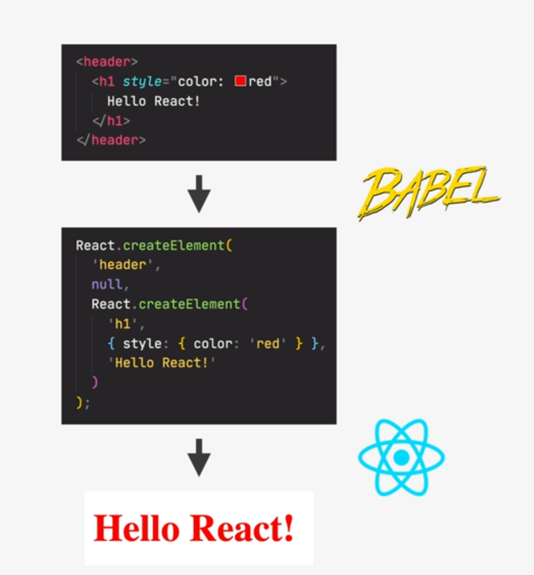

**Declarative vs. Imperative:**

* Imperative Approach: Traditional JavaScript where developers give step-by-step instructions to manipulate the DOM directly.
* Declarative Approach: React approach using JSX to describe what the UI should look like based on the current data, without manual DOM manipulation.
* React abstracts the DOM, automatically synchronizing the UI with the underlying data (props and state).

**Advantages of JSX and Declarative Programming:**

* Simplifies complex UI development by focusing on "what" the UI should be rather than "how" to achieve it.
* Improves readability and maintainability of code by avoiding direct DOM manipulation and manual updates.

